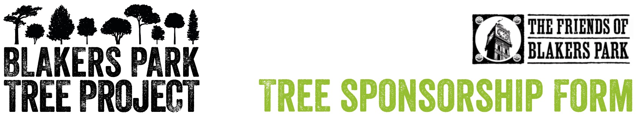

Sponsoring your very own new tree in the park couldn’t be easier.

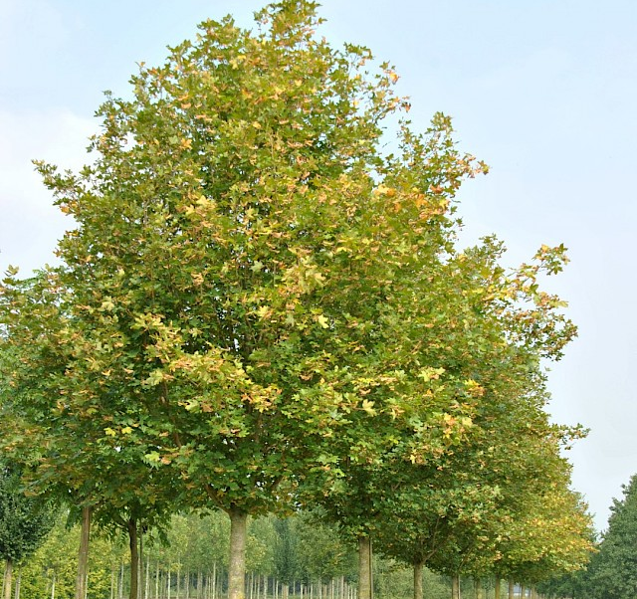 | 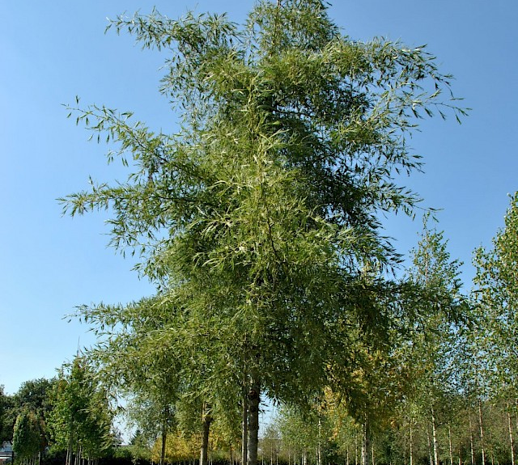 | 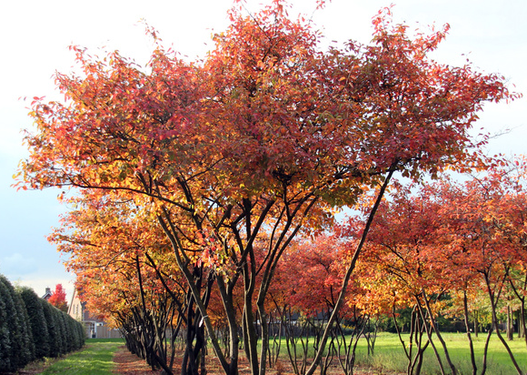 | 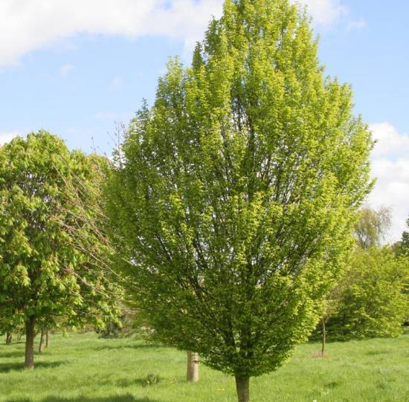 | 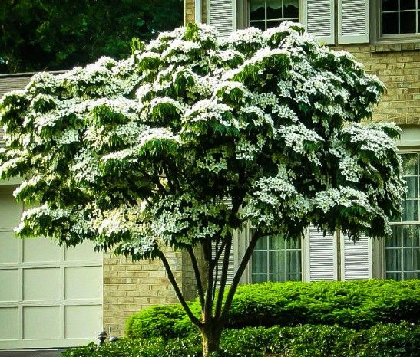
Field Maple | Alder | Juneberry | Hornbeam | Kousa Dogwood
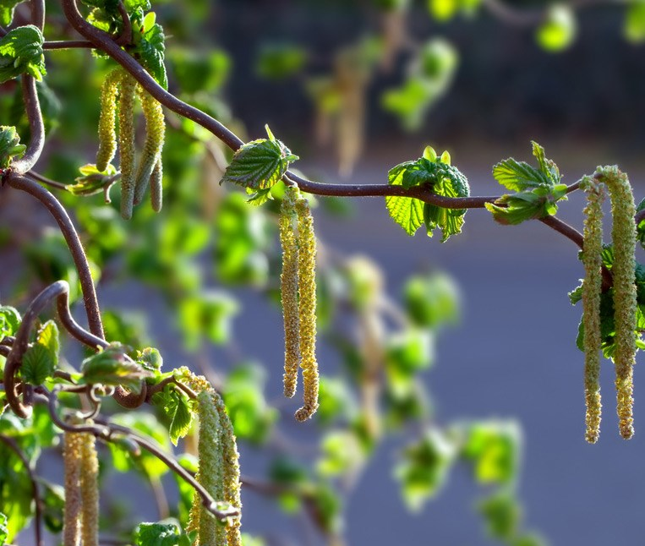 | 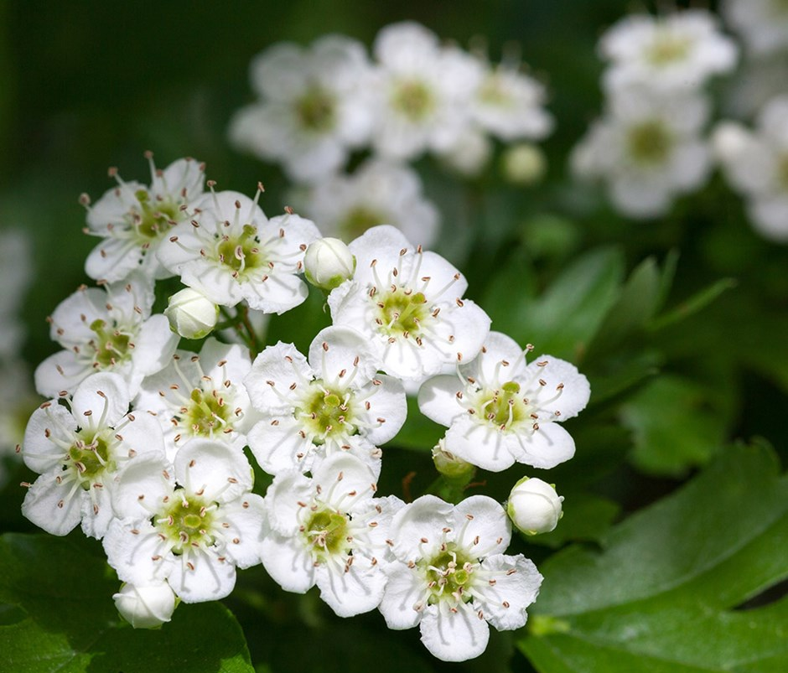 | 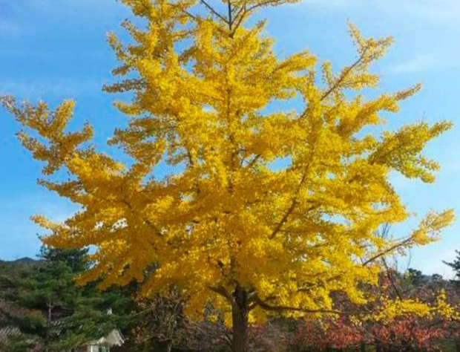 | 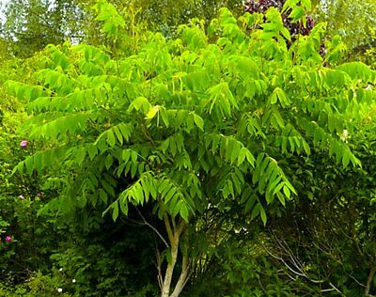 | 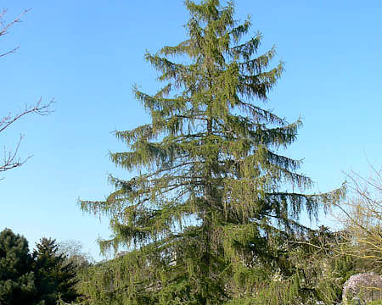
Hazel | Hawthorn | Ginko | Manchurian walnut | Common Larch
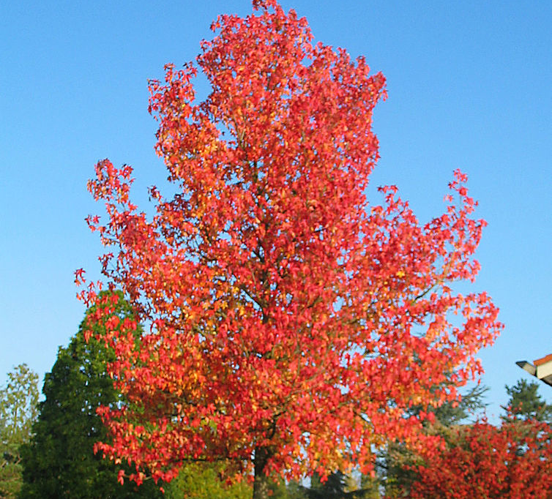 | 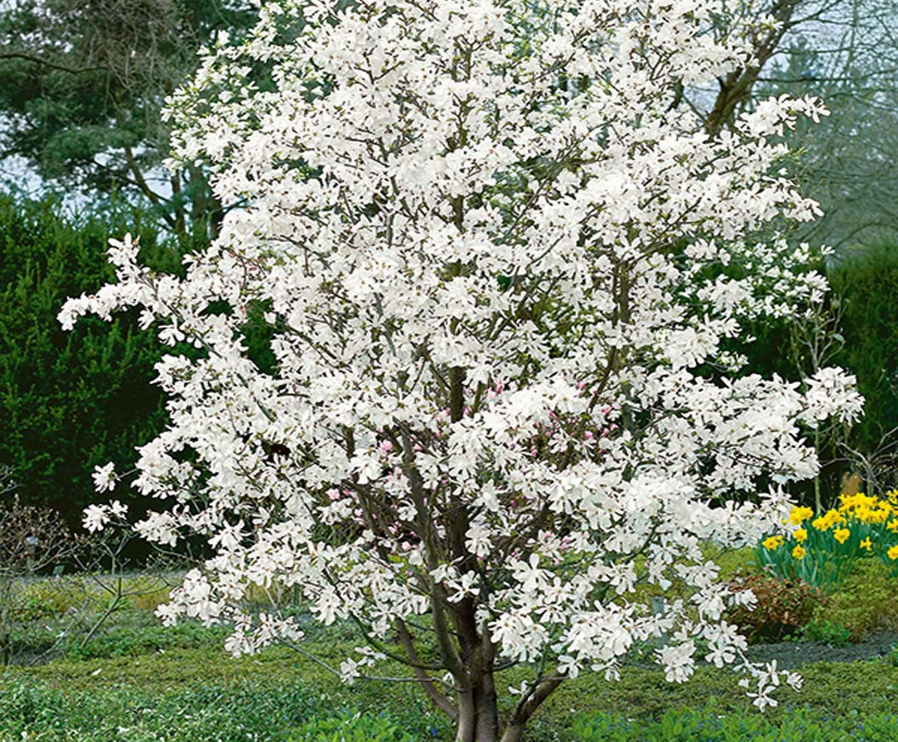 | 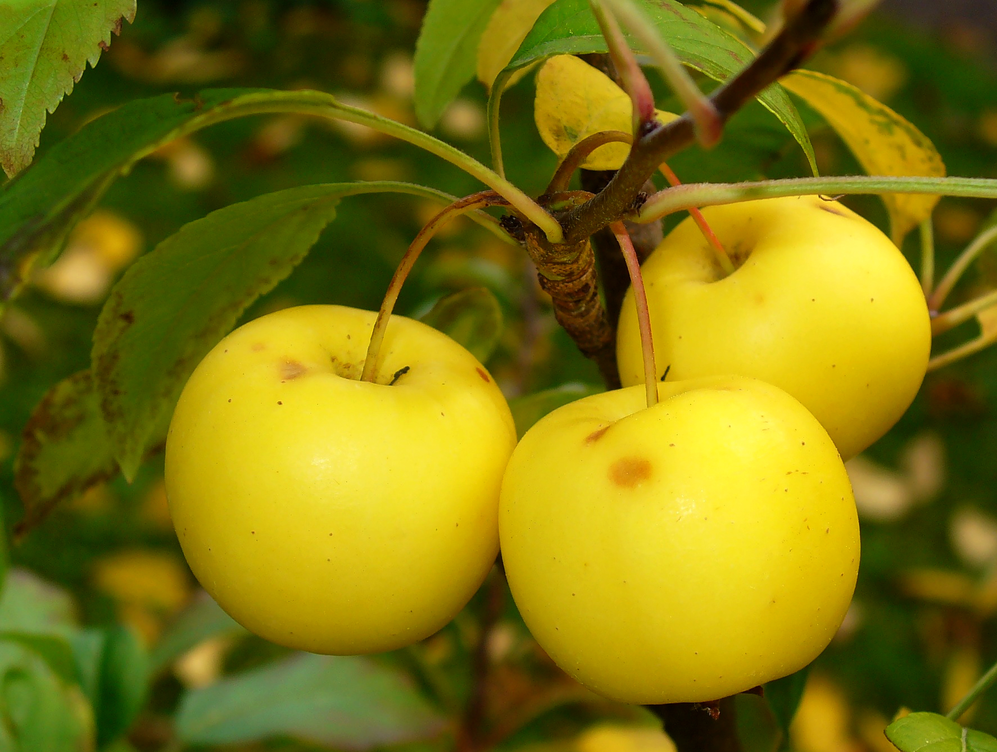 | 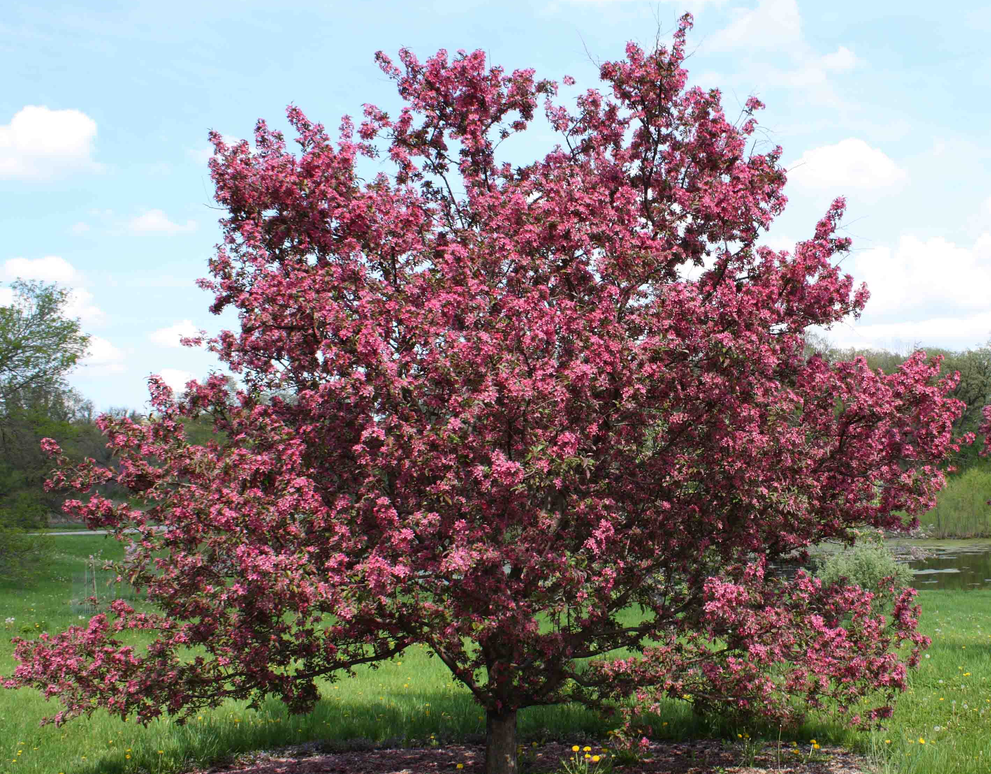 | 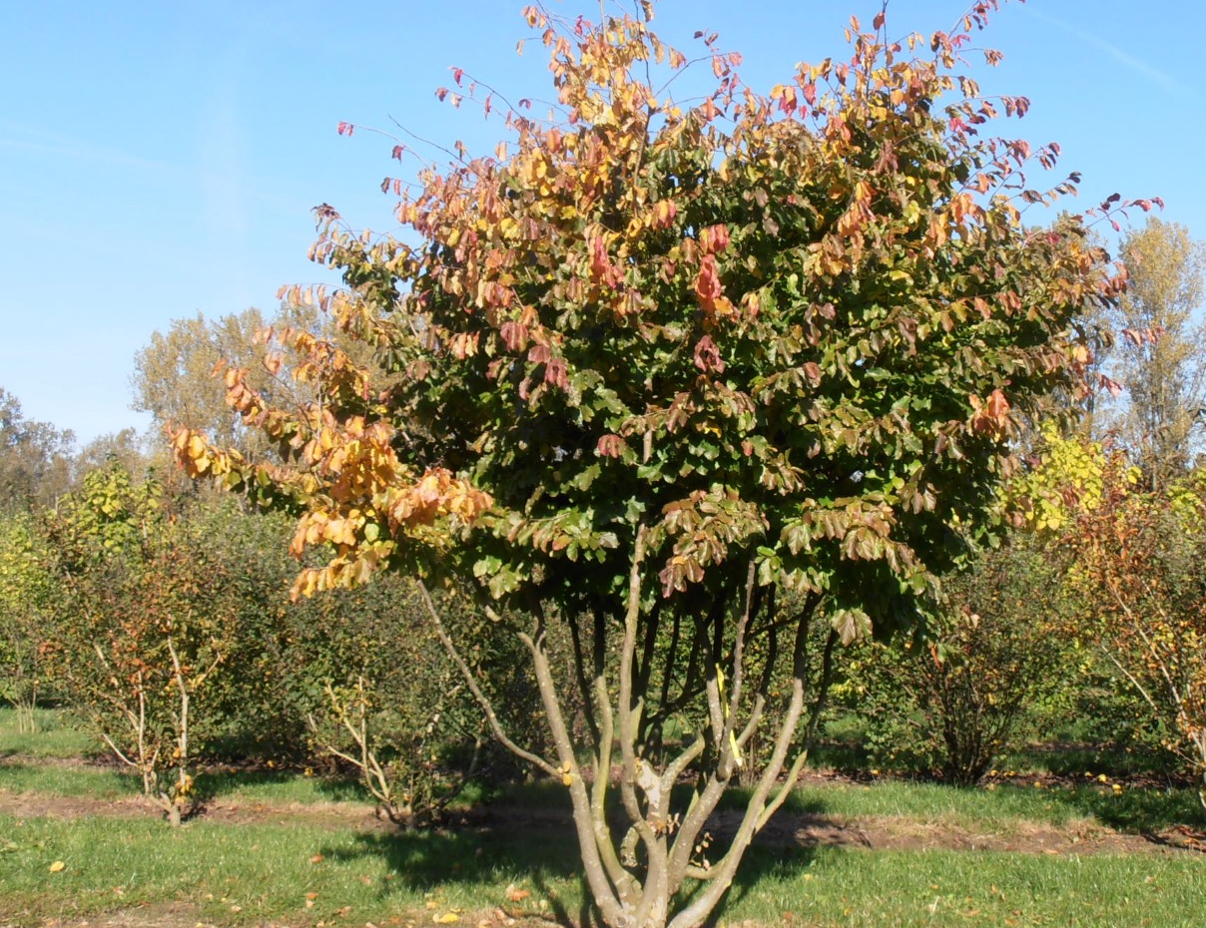
Sweetgum | Magnolia | Crab apple | Crab apple red | Persian ironwood
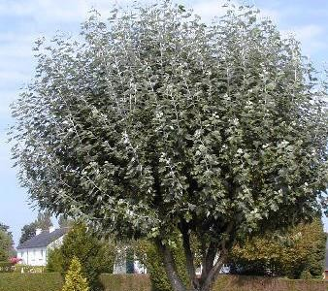 | 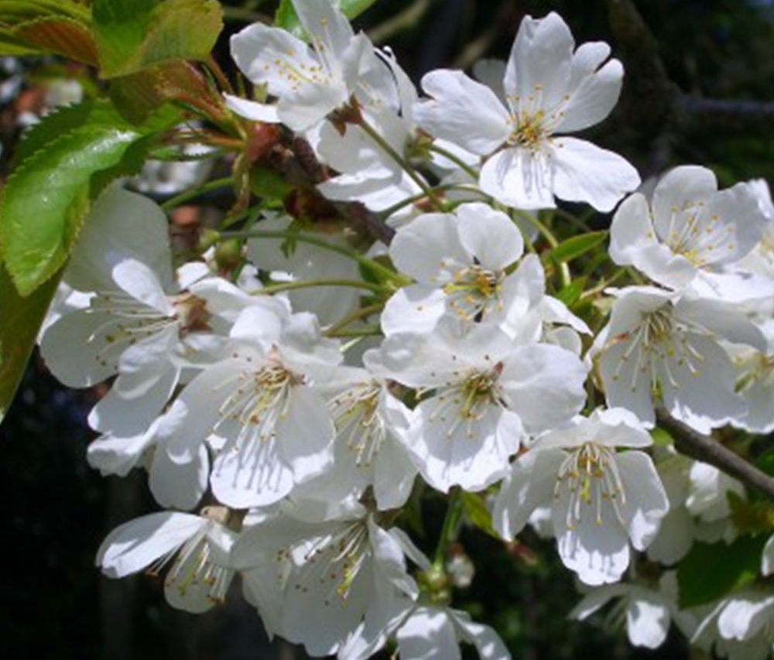 | 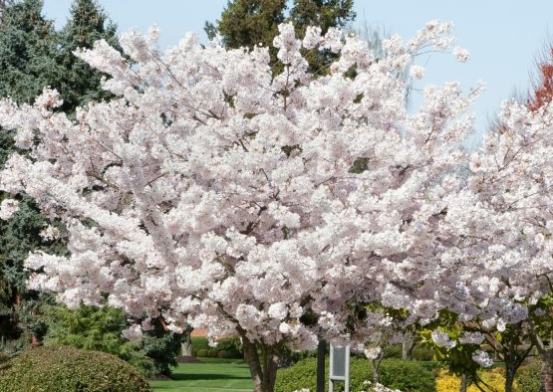 | 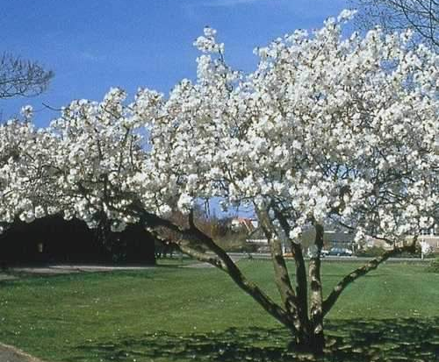 | 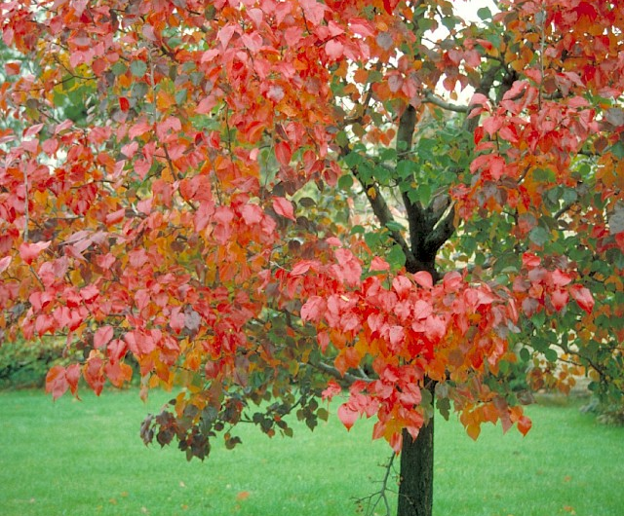
White Poplar | Wild Cherry | Mount Fuji Cherry | Great White Cherry | Pear
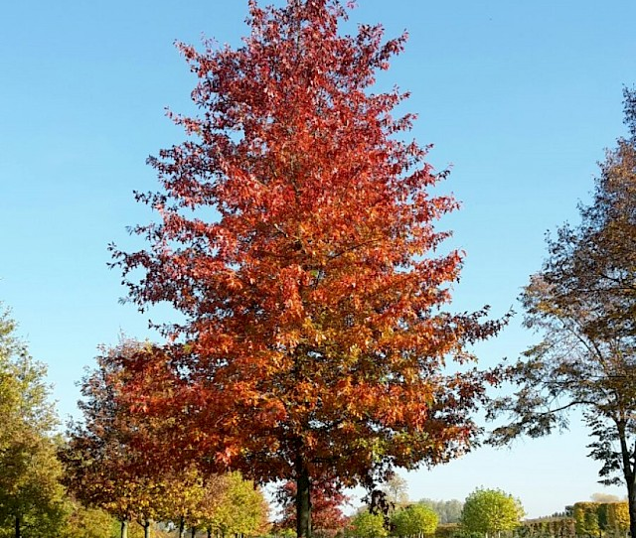 | 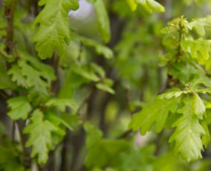 | 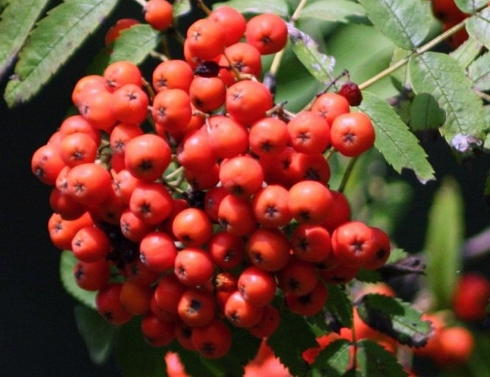 | 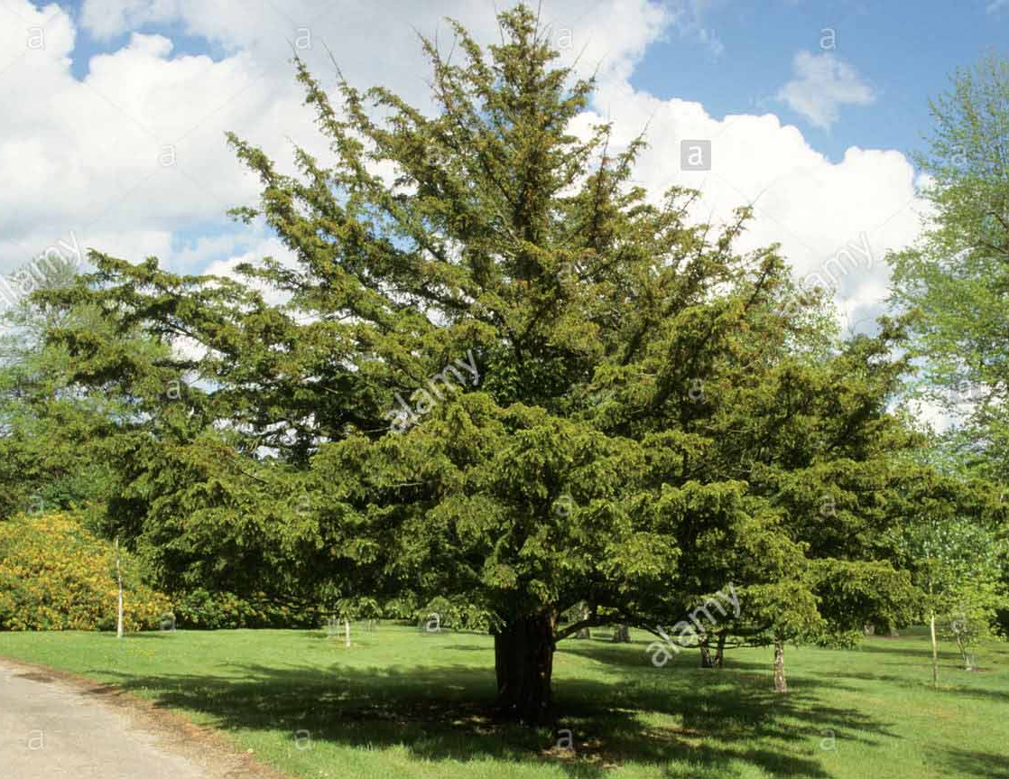 | 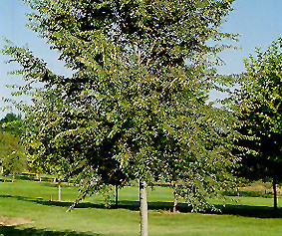
Pin Oak | Pyramid Oak | Rowan | Yew | Elm

1. Please highlight your preferred choice of tree in red:

Field Maple (Acer campestre) £250 ea
Alder (Alnus glutinosa ‘Imperialis’) £180 ea
Alder (Alnus incana 'Pendula') £180 ea
Juneberry (Amelanchier lamarckii) £250 ea
Juneberry (Amel. 'Autumn Brilliance') £250 ea
Hornbeam (Carpinus betulus 'Purpurea') £300 ea
Kousa Dogwood (Cornus mas) £450 ea
Kousa Dogwood (Cornus officinalis) £450 ea
Hazel (Corylus avellana) £450 ea
Hawthorn (Crataegus monogyna) £350 ea
Ginko (Ginkgo biloba) £345 ea
Manchurian walnut (Juglans mandshurica) £250 ea
Common Larch (Larix decidua) £400 ea
Sweetgum (Liquidambar styraciflua) £140 ea
Magnolia (Magnolia x loebneri ‘Merrill’) £240 ea

Showy Crab apple (Malus floribunda) £350 ea
Crab apple (Malus 'John Downie') £350 ea
Crab apple Red (Malus sylvestris 'Red Sentinel') £350 ea
Persian Ironwood (Parrotia persica ‘Vanessa’) £450 ea
White poplar (Populus alba 'Nivea') £150 ea
Wild Cherry (Prunus avium ‘Plena’) £110 ea
Mount Fuji Cherry (Prunus serrulata 'Shirotae') £350 ea
Great White Cherry (Prunus 'Tai-haku') £325 ea
Pear (Pyrus calleryana 'Autumn Blaze') £250 ea
Pin Oak (Quercus palustris) £249 ea
Pyramid Oak (Quercus robur ‘Fastigiate Koster’) £274 ea
Rowan (Sorbus aucuparia ‘Sheerwater Seedling’) £111 ea
Rowan (Sorbus torminalis) £275 ea
Yew (Taxus baccata) £450 ea
Resistant Elm (Ulmus 'Homestead' or ‘New Horizon) £350 ea

Whilst every effort will be made to plant your first choice, we have a responsibility to ensure diversity of tree species in our planting programme so we may contact you to recommend a tree of similar cost if that is the case.

2. About you:

My name: <please complete>
My preferred contact: <please complete>

I am sponsoring a tree in Blakers Park because <please complete as appropriate>

I understand that my tree may be planted next winter if this year's planting window has closed and that you will keep me informed. YES / NO <please delete as appropriate>

I understand that my tree will need some aftercare and I'm up for helping! YES / NO <please delete as appropriate>

3. Payment:

You can email this completed form to us at friendsofblakerspark@gmail.com and pay by BACS to:
Sort Code 40-11-58 Account Number 20226262 Reference: <yoursurnameTREE>
OR
You can print and post this completed form to Friends of Blakers Park, 77 Chester Terrace, Brighton BN1 6GD
and include a cheque made out to Friends of Blakers Park
OR
You can print and post this form and pay by BACS to:
Sort Code 40-11-58 Account Number 20226262 Reference: <yoursurnameTREE>

4. We will be in touch to confirm receipt of your form and payment.

How planting and aftercare works

In partnership with Brighton and Hove City Council we will plant trees between November and April each year. Our group member and landscape architect Phil Allen, together with a Council Tree Officer will agree final tree species and location subject to our park tree survey, and then contact you to discuss the planting and confirm details.

The Council have an aftercare programme in place for all new trees, during the first year after planting sponsored trees will be monitored and watered. You can help your new tree develop by giving them additional water during the first three years after planting, especially during long periods of dry weather.

We will aim to plant all trees in a secure fashion with the protection of stakes, however theft and vandalism of trees in parks is a risk. Whilst we will make every effort to maintain sponsored trees whenever possible, we reserve the right to remove it if it is damaged beyond repair. If this is the case, or if a tree is stolen, there is no guarantee that we will be in a position to replace it.

Privacy Policy

As you sponsored a tree we will keep your personal data securely on our secure Tree Sponsor List and only use it to contact you about the Tree Project. Under no circumstances will we share your details with any third party. You can let us know anytime if you would like to be removed from our List by emailing us at friendsofblakerspark@gmail.com

Thanks for your support!

